**Chapter 1**

**Introduction**

* 1. **Motivation**

The aim of this research is to develop a cloud computing project, where the users can use their external hard drive’s connected to Raspberry Pi through internet they can have access to anywhere from any device. According to (Jon Brodkin, 2008) Even though Security, Privacy and Trust issues exists since the evolution of Internet, the reason why they are widely spoken these days is because of the Cloud Computing scenario. Any client/small organization/enterprise that processes data in the cloud is subjected to an inherent level of risk because outsourced services bypass the "physical, logical and personnel controls" of the user.

To develop a cloud computing project where users can have large amount of storage with the help of Raspberry Pi. Most of the user have external hard drive 1 TB (Terabyte) or more but the users cannot carry the external hard drives all the time, whereby this project will benefit the users connect to personal cloud storage over internet. The new technology which will be affordable to everyone and also it will enable the user to use their external hard drives over internet possible.

Laptops that the lecturers are using for slides provided by Limkokwing University are limited in quantity and most of them are not working (requires maintenance). Replace all the laptops with the Raspberry Pi, which only cost $35 and does not require maintenance (low maintenance). The laptop cost is above $300 and need maintenance but the Raspberry Pi cost is $35 and does not need any maintenance. Raspberry Pi will reduce the cost and effort for lecturers, also it is easy to carry.

Most of the cloud computing services are providing limited storage to the users, at the same time the risk of your data to store at third party is a big issue. Example is the recent incident of exposed nude pictures of the celebrities from iCloud. Which is a clear example that our data is not safe, to overcome these problems this research will come up with the perfect solution with unlimited cloud data storage by the help of “Raspberry Pi”.

The need for agile, flexible, and cost-efficient computer networks has formed the nucleus for the global efforts toward software-defined networking (SDN). SDN is an emerging approach to computer networking that separates the tightly coupled control and data (forwarding) planes in traditional networking devices. Thanks to this separation, SDN can provide a logically central- ized view of the network in a single point of management. This is achieved via open interfaces and abstraction of lower-level functionalities and transforms the network to a programmable platform that can dynamically adapt its behavior. SDN is becoming so popular that its usage has spread beyond ordinary networks and is even suggested to address the challenges of smart-grid.

Cloud computing is a successful computing paradigm that delivers computing resources residing in providers’ datacenters as a service over the Internet on a pay-as-you-go basis. With the grow- ing adoption of cloud computing, datacenters hosting cloud services are rapidly expanding their sizes and increasing in number. Therefore, resource management in clouds’ large-scale infra- structure becomes a challenge.

In the meantime, SDN is increasingly being accepted as the technology for a new generation of networks in cloud datacenters, where the need exists for efficient management of large mul- titenant networks of dynamic, ever-changing environments. In fact, SDN not only reduces the complexity seen in today’s cloud datacenter networks but also helps cloud providers manage net- work services from a central management point.

The fruitful combination and deployment of cloud computing and SDN require significant innovation and research to fuse them together. However,evaluation and experimentation of SDN-based applications for cloud environments present many challenges in terms of complexity, scaling,accuracy,andefficiency. The major classes of performance evaluation techniques for these methods can be categorized as analytical modeling, simulation, emulation, and measurement.

* 1. **Timeline / Evolution**

Cloud computing is believed to have been invented by [Joseph Carl Robnett Licklider](https://en.wikipedia.org/wiki/Joseph_Carl_Robnett_Licklider) in the 1960s with his work on [ARPANET](https://en.wikipedia.org/wiki/ARPANET) to connect people and data from anywhere at any time.

In 1983, [CompuServe](https://en.wikipedia.org/wiki/CompuServe) offered its consumer users a small amount of disk space that could be used to store any files they chose to upload.

In 1994, [AT&T](https://en.wikipedia.org/wiki/AT%26T) launched PersonaLink Services, an online platform for personal and business communication and entrepreneurship. The storage was one of the first to be all web-based, and referenced in their commercials as, "you can think of our electronic meeting place as the cloud."[[3]](https://en.wikipedia.org/wiki/Cloud_storage#cite_note-3) [Amazon Web Services](https://en.wikipedia.org/wiki/Amazon_Web_Services) introduced their cloud storage service [AWS S3](https://en.wikipedia.org/wiki/AWS_S3) in 2006, and has gained widespread recognition and adoption as the storage supplier to popular services such as [SmugMug](https://en.wikipedia.org/wiki/SmugMug), [Dropbox](https://en.wikipedia.org/wiki/Dropbox_(service)), and [Pinterest](https://en.wikipedia.org/wiki/Pinterest). In 2005, [Box](https://en.wikipedia.org/wiki/Box_(company)) announced an online file sharing and personal cloud content management service for businesses.

* 1. **Organization of report**

The Report is divided into Five Chapters. In Chapter 2, is all discussion about Literature Review that covers fundamental of topic, existing method and its pros and cons. Chapter 3, is about Methodology and Mathematical model. In Chapter 4, it is all discussion about Result. Finally Chapter 5, consists of Conclusion and Future work.

**Chapter 2**

**Literature Review**

According to William (2014), in order to do effective way of computation, Cloud Computing offers IaaS, PaaS and SaaS levels of service models. The

lowest service model is called Infrastructure as a Service (IaaS), which follows by Platform as a Service (PaaS) and last, but not least Software as a Service (SaaS). Each service model helps to add more functionality and abstraction to the technical details.

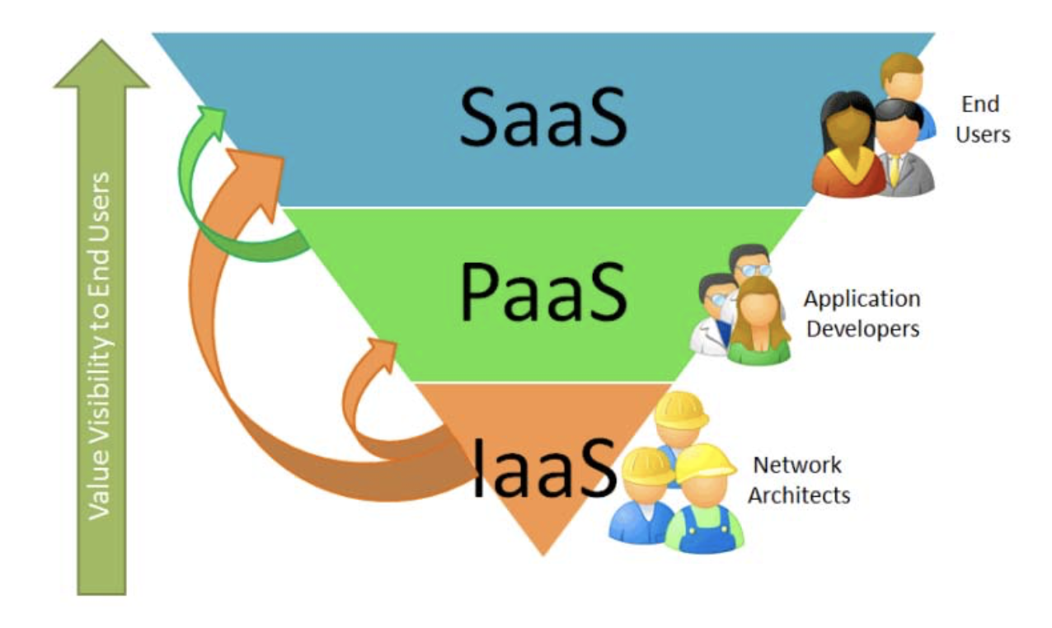

Fig 2.1 Cloud Computing Stack (Schuller, 2010)

The National Institutes of Standards and Technology (NIST) definition runs to several hundred words but essentially says that:

“*Cloud Computing is a model for enabling convenient, on-demand network access to a shared pool of configurable computing resources (e.g., networks, servers, storage, applications, and services) that can be rapidly provisioned” and released with minimal management effort or service provider interaction.”*

Armbrust (2009) defined clouds as computers are being able to network anywhere in the world by per- per-use way to pay for used clouds, the actual meaning of this idea is that the resources that are being used will be paid only. Below will be introduces types of clouds. The first one is the Public Clouds. Armbrust (2009) mentioned that public cloud is the traditional cloud computing that will have the opportunity to access to the computing resources from anywhere of the world. The pay-per-use manner will be used in clouds, as defined the only resources that are being used will be paid by transaction fees. On a superficial level, my findings may seem self-evident: a technology company tells its users what it expects of them and users for the most part agree, so long as the technology holds up. However, if we dig deeper, we can extract some important implications from this research. Following the work of other scholars who look at trust in information and communications technologies, I believe that trust is a more useful concept for studying the implications of new technologies than simply looking at privacy.

Cloud Computing Deployment Models

There are four deployment models for cloud computing, depending on the owners requirement, the security issues starts from here.

Public cloud computing is based on large-scale offering to general public, the infrastructure is located at premises of provider. The provider owns and manages the cloud infrastructure.

In this case the infrastructure is provisioned for exclusive use by a single organization. It can be owned, managed, and operated by the organization themselves, a supplier as a third party, or some combination of them. Additionally it can exist on or off premises of the organization (Mell/Grance, 2011). Therefore special forms, can be also considered as a private Clouds. These are listed by some researchers as e.g. virtual private Clouds (e.g. Ried et al. 2011), where the cloud is hosted on dedicated, virtual machines in the data center of the Cloud provider, as well as managed private clouds, where the cloud is hosted by a third party in the data center of the customer.

However, what makes this analysis different than other literature on trust – and what this project is ultimately about on a theoretical level is the nexus of technology, objectivity and trust. A word about each and how they relate is necessary. My analysis and understanding of technology rests on many of the assumptions of actor-network theory, and particularly Bruno Latour’s (1991) quip: “Technology is society made durable.” I have extensively used the metaphor of the black box to exemplify this principle and stay faithful to the central tenets of Raspberry Pi Cloud Storage. The black box represents a network of associated humans and non-humans that has stabilized such that its heterogeneity is reduced and it appears as a homogenous whole. Its associations (i.e., its social *The Public Cloud*Public cloud computing is based on large-scale

offering to general public, the infrastructure is located at premises of provider. The provider owns and manages the cloud infrastructure.

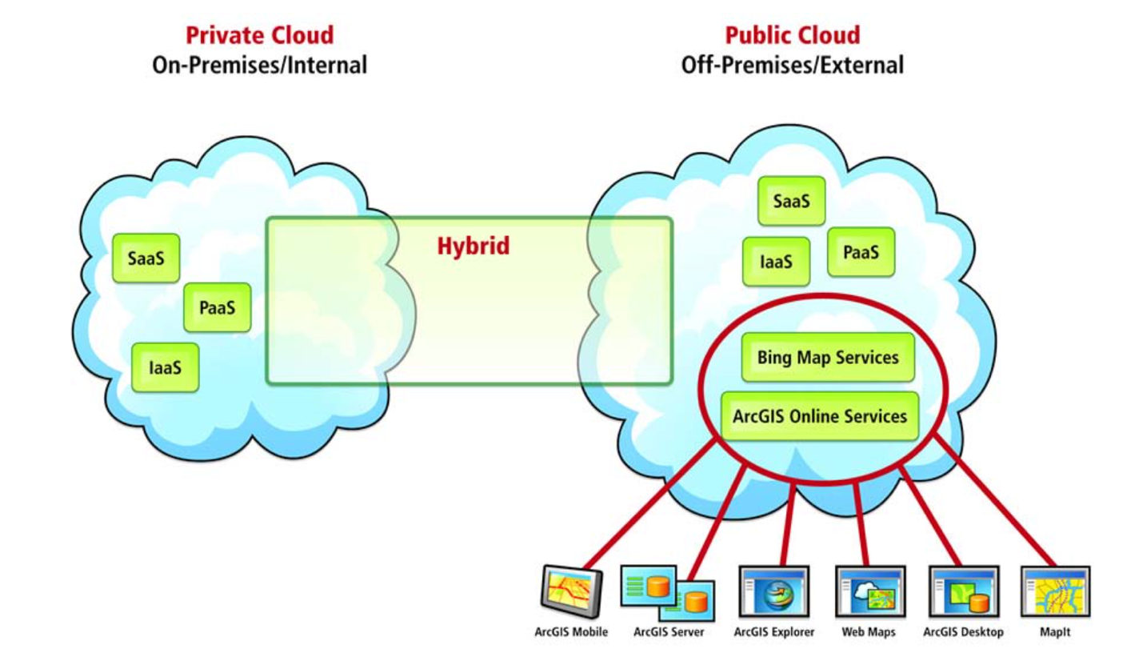

Fig 2.2 Image representing the clear idea of Cloud Computing Deployment Models

The fruitful combination and deployment of cloud computing and SDN require significant innovation and research to fuse them together. However , evaluation and experimentation of SDN- based applications for cloud environments present many challenges in terms of complexity, scaling , accuracy , and efficiency. The major classes of performance evaluation techniques for these methods can be categorized as analytical modeling, simulation, emulation, and measurement.

If we exclude analytical modeling owing to its limitations and complexity, simulation tools (e.g., CloudSimSDN) play a significant role in the performance evaluation of these methods owing to their flexibility and affordability. However, simulations always present imperfect models and are limited in their ability to reproduce real-world software-defined clouds (SDCs).

Emulation techniques, on the other hand, seem to be the method of choice for achieving a de- tailed understanding of the operation of SDCs. Software emulators (e.g., Mininet) expedite pro- totyping of SDN on a single machine. But there is not enough support for network dynamicity and the performance measurement of the virtualized hosts and virtual machines (VMs) in such tools. Rapid and affordable prototyping of algorithmic advances in SDCs is challenging , and significant capital expenditure is required to replicate practical implementations and performance measurements.

With these issues in mind, this article puts together all the elements to build a low-cost micro software-defined datacenter by leveraging off-the-shelf hardware and open source software. We propose a system architecture for constructing a testbed and micro datacenter for researching SDCs. We focus on the cost-effectiveness of our setup by reusing existing equipment and coping with the budget and space limitations of an academic research laboratory.

One of the most important benefits of SDN is that commodity hardware can be used to build net- working devices. Therefore, we use Raspberry Pis, low-cost and small single-board computers, to create a small-scale datacenter network. To make a network switch out of a Raspberry Pi, we integrate each Pi with an Open vSwitch (OVS), which is one of the most widely used virtual switches in SDN.

**Chapter 3**

**Methodology**

**3.1 Motivation**

Maxwell (2012) has stated that ‘the strengths of qualitative research derive primarily from its inductive approach’. The reason why the inductive approach was used in this research due to the newness of the idea to create your own cloud with Raspberry Pi. A deductive ‘approach to this subject would risk restricting the potential avenues of investigation. The inductive approach necessitated attempting to understand the meaning and the context of people‘s responses to the adoption of Cloud Computing. It attempted to uncover unforeseen trends and detect linkages between Cloud Computing and Raspberry Pi.

* + 1. Data Collection

The focus is on using qualitative data collection techniques. Qualitative data is data that is focusing on delivering information that can be described with terms and theories. It is not like quantitative research that focuses on the numbers behind a survey or something similar. It focuses on delivering numbers and information in terms of quantity. Qualitative research can be interviews or observations where the research is done on the behaviour or theories (Saunders et.al.2010).

Our research will consist of both primary and secondary data. Primary data is data collected by the researcher using different methods. The primary data that is collected are often more reliable due to that you know where the data comes from and been following the progression all the way

Secondary data are data that is collected from external sources that already exist. The only thing that has to be done is to look for the data you need. Secondary data has the upside compared to primary that it is cheaper to collect but the reliability, validity and accuracy is not as great. You do not know where the data actually comes from and cannot fully trust is against primary data where you have more control.

There is a third data source called tertiary data that is the search tools for obtaining secondary and primary data such as encyclopaedias and indexes. Often it is used in literature search when not knowing where to start searching for a specific topic (Saunders et.al. 2012). Our primary data collection will consist observation in different forms and the secondary data collection will be recent articles in the area of cloud computing and raspberry Pi, internet sources and literature that is within our field of research.

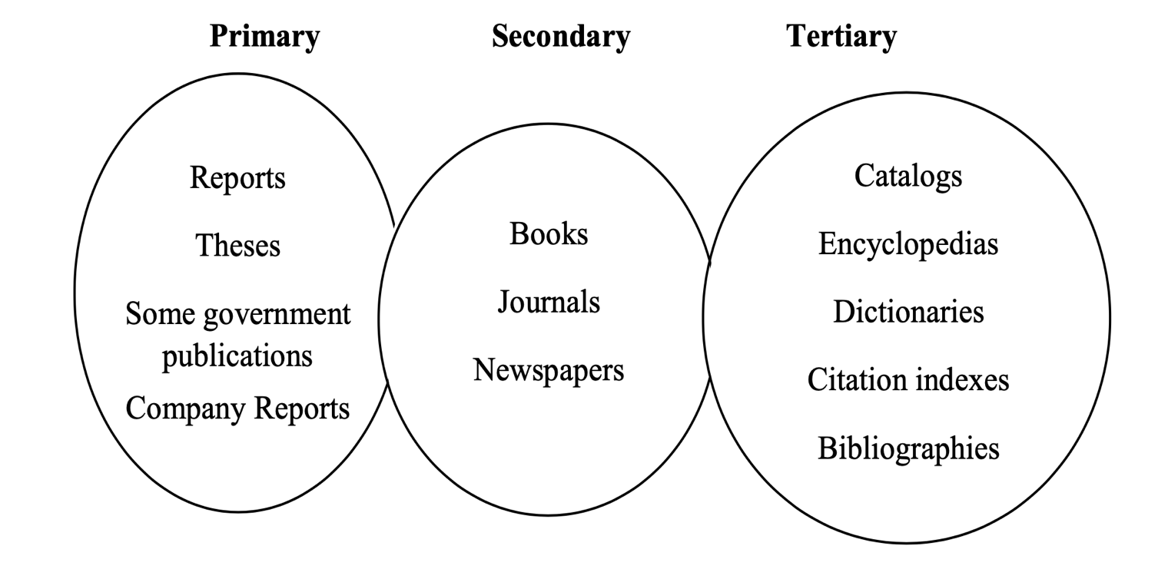

Fig 3.1 The different literature sources (Saunders et.al. 2009)

* 1. **SYSTEM ARCHITECTURE**

In this section, we present the CLOUDS-Pi platform along with the physical-infrastructure setup and utilized software . In contrast to other work in this domain , such as Zebra or Elasticcon , that particularly focuses on architectural frameworks for advancing SDN controllers, we intend to use current advances in SDN and cloud technologies to put together a recipe for constructing a plat- form for conducting empirical research in SDCs.

* + 1. Physical Infrastructure

The primary aim of our small cloud datacenter is to provide an economical testbed for conducting research in SDCs. Therefore, we focus on reusing existing infrastructure, equipment, and machines (hosts) connected through a network of OpenFlow switches made out of Rasp-berry Pis, used by others as computational resources. Our platform comprises a set of nine heterogeneous machines with the specifications shown in Table. To keep up with common practice, we use separate networks for management, data, and control.

Table 3.1 Specifications of machines in CLOUDS-Pi.

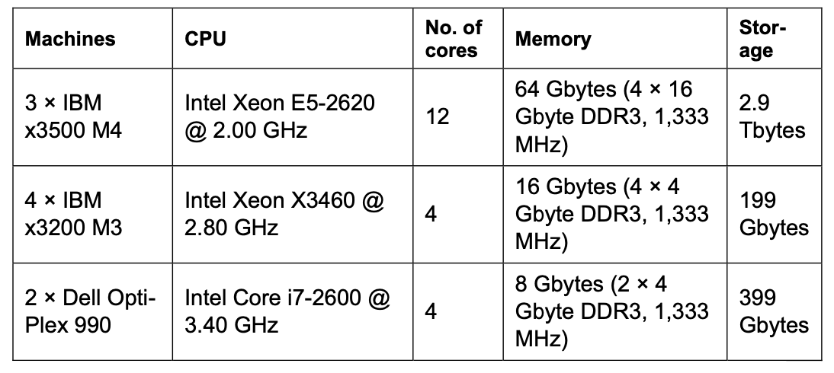

The management network is used by OpenStack, our deployed cloud OS, for internal communi- cation between its components and resource management. It constitutes a 16-port 10/100 Mbps Ethernet switch (NetGear Model FS516) connecting the hosts and OpenStack controller.

The data network is used for data communication among VMs deployed within the cloud envi- ronment and for providing Internet access to them through the gateway host. This network is a 100 Mbps fat-tree-like network10 built on top of 10 Raspberry Pis (Pi 3 Model B) with OVS inte- grated, each playing a role of a 4-port switch with an external port for control. Each Raspberry Pi 3 Model B has four USB 2.0 ports and only one Ethernet interface. Therefore, we used TP-Link UE200 100 Mbps USB-to-Ethernet adapters to add four extra Ethernet interfaces to the Rasp- berry Pi switch.

The control network connects control ports on the Raspberry Pi switches to the SDN controller and transfers OpenFlow packets between the controller and the switches.

To monitor the power consumption of individual machines, all cluster nodes are connected to two Eaton EMAB03 vertical managed enclosure power distribution units (ePDUs). Eaton ePDUs allow us to monitor and switch on and off power outlets connected to an individual machine re- motely through the network. These measurements can be used to evaluate the energy efficiency of the testbed and developed algorithms.

Figure 1 depicts our datacenter setup, including the network topology for the management, data, and control networks. Figure 2 depicts the CLOUDS-Pi platform.

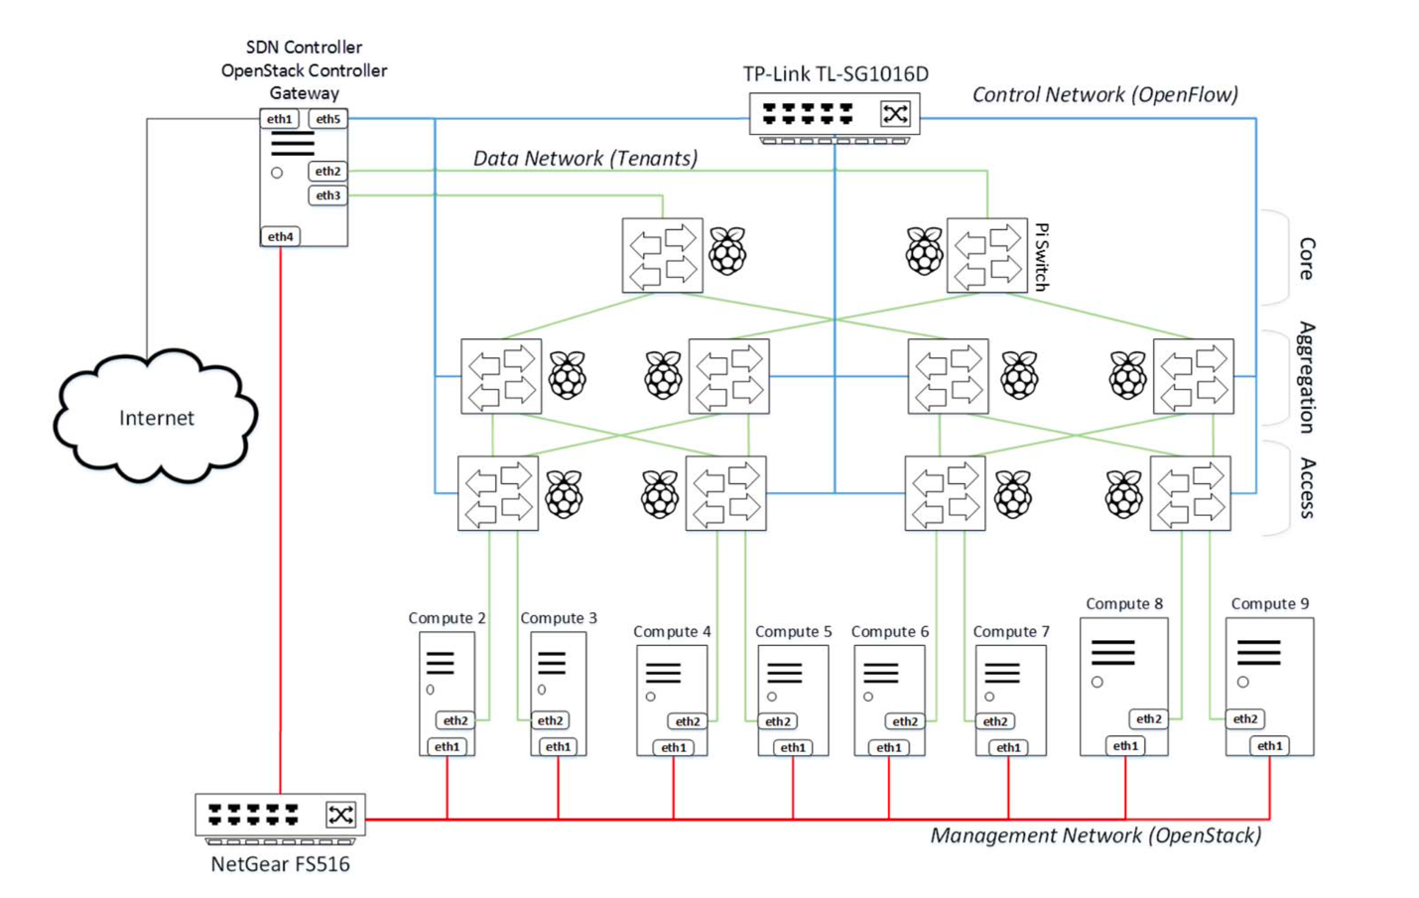

Fig 3.2 The system architecture of CLOUDS-Pi.

* + 1. Software

We installed the CentOS 7.0 Linux distribution as the host OS on all nodes. Then, using RDO Packstack, we installed OpenStack to build our cloud platform. Given that the OpenStack con- troller resides beside the SDN controller, we used one of our more powerful machines (an IBM X3500) as the controller node. All other nodes play the same role of computation hosts in the design. In addition, we created NAT (network address translation) forwarding rules on the controller, using Linux iptables to enable all other nodes to connect to the Internet. In this way, the control- ler node is configured as the default gateway for external network access (Internet access) for all other nodes and OpenStack VMs. We also set up an L2TP/IPsec virtual private network (VPN) server using Openswan and xl2tpd Linux packages on the controller node to provide direct ac- cess to VMs for our cloud users outside the datacenter network.

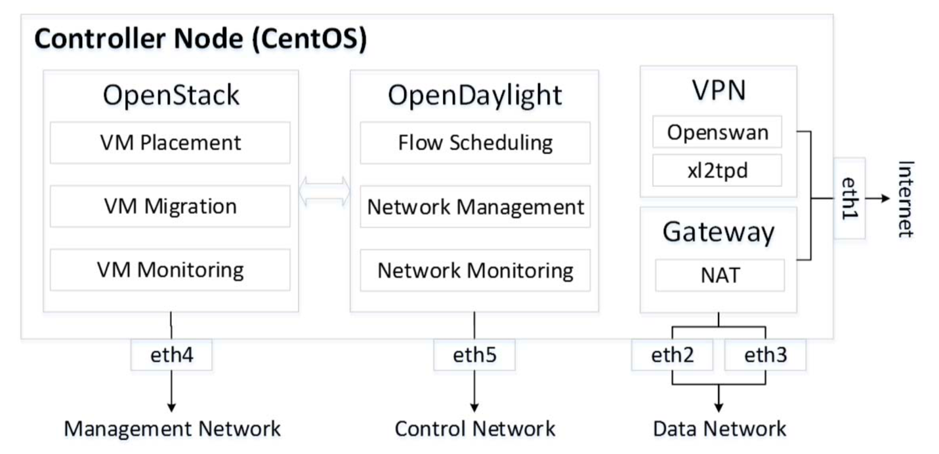

Fig 3.3 The software stack on the controller node. VM = virtual machine, VPN = virtual private network, eth = Ethernet interface, and NAT = network address translation.

CLOUDS-Pi uses OpenDaylight (ODL), one of the popular open source SDN controllers, to pro- vide the brain of the network and handle OpenFlow-capable Raspberry Pi switches. ODL is in- stalled on the same host as the OpenStack controller and manages OpenFlow switches via the control network (see Figure 3). Every Raspberry Pi in our setup uses a Debian-based Linux OS of Raspbian Version 8 (Jessie) and has OVS version 2.3.0 installed as an SDN-capable virtual switch. We configured OVS as a software switch having all USB-based physical interfaces con- nected as forwarding ports and used Raspberry Pi’s built-in interface as an OpenFlow control port.

We also developed some open source tools (https://github.com/Cloudslab/sdcon) to provide inte- grated manageability and monitoring for our platform. For example, the Status Visualizer is a tool implemented to visualize traffic flows among hosts and VMs in the network. This module retrieves the topology information and then plots network links along with the real-time moni- tored flows with different colors, where the thickness of the connector line represents the used bandwidth. Figure 4 depicts the screenshot of the Status Visualizer web UI showing sample traf- fic in CLOUDS-Pi between groups of VMs.

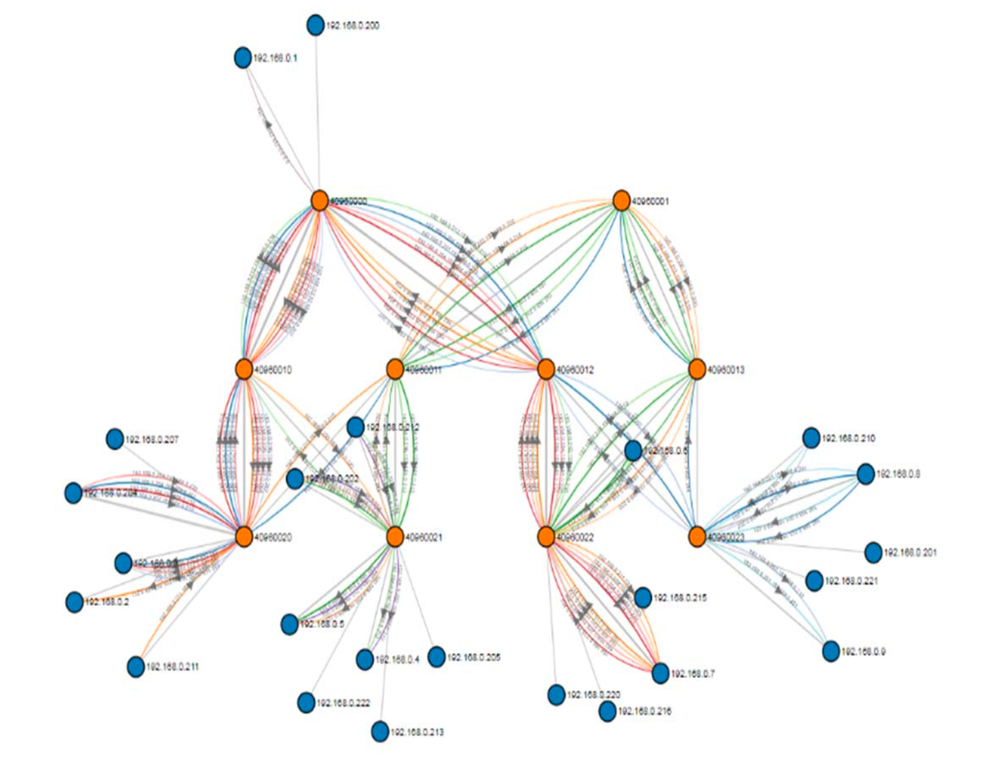

Fig 3.4 Sample network traffic in CLOUDS-Pi visualized by the Status Visualizer.

* 1. **USE CASES**

We introduce two use cases to illustrate how the CLOUDS-Pi platform and its SDN-enabled fea- tures can be utilized to offer solutions and drive research innovations. The first use case shows dynamic flow scheduling for efficient use of network resources in a multirooted tree topology. The second use case demonstrates that the communication cost of pairwise VM traffic can be reduced by exploiting collocation and network locality through live VM migration.

* + 1. Dynamic Flow Scheduling

Datacenter network topologies such as fat trees typically consist of many equal-cost paths be- tween any given pair of hosts. Traditional network forwarding protocols often select a single de- terministic path for each pair of source and destination, and sometimes protocols such as equal- cost multipath (ECMP) routing are used to evenly distribute the load on multiple paths. This static mapping of flows to paths does not take into account network utilization and the duration of flows. We propose and demonstrate the feasibility of building dynamic flow scheduling for a given pair of hosts in our multirooted-tree testbed using ODL APIs.

The key insight is to iteratively redirect a flow of interest (e.g., VM migration traffic) to one of the shortest paths with the lowest load when multiple shortest paths are available between the source and destination. In an SDN-enabled datacenter, this can be simply performed by a flow entry setup on the switches along the path, which can be configured centrally and then propa- gated throughout the entire path.

As input, the algorithm receives the IP addresses of a given pair of hosts and specifications of the target flow (e.g., the protocol and source and destination ports). It then finds multiple paths of equal length between the source and the destination and iteratively measures the average byte rate on the path for the last time interval (e.g., every 15 seconds). Since the target flow happens through one of the shortest paths, we have to make sure that the byte rate of the flow is excluded from the calculation. Thus, the byte rate for the matching flow is deducted from the total calcula- tion.

As soon as the shortest path with the lowest average byte rate between the source and the desti- nation is found, appropriate flow rules are pushed into the switches on the path to redirect the flow to this path. In line with this idea, we are working on a more advanced version of a dy- namic-flow-scheduling algorithm for efficient migration of VMs in SDCs.

To evaluate the impact of the proposed dynamic flow scheduling on bandwidth, using ipref3 in TCP mode, we generated 10 synthetic and random flows between different hosts in the network. We measured the transmission time and available bandwidth for the flow of interest (given a pair of hosts) with or without enabling dynamic flow scheduling.

Figure 5 shows a graphical representation of the network topology detected by the ODL User Interface (DLUX), along with the labeled given pair of hosts. Table 2 shows the available band- width and transmission time for 700 Mbytes of data between the given hosts. Enabling dynamic flow scheduling reduced the transmission time by 13.6% compared to the static-routing method. The average bandwidth also improved from 35.24 Mbps with no flow management to 40.61 Mbps with dynamic flow scheduling.

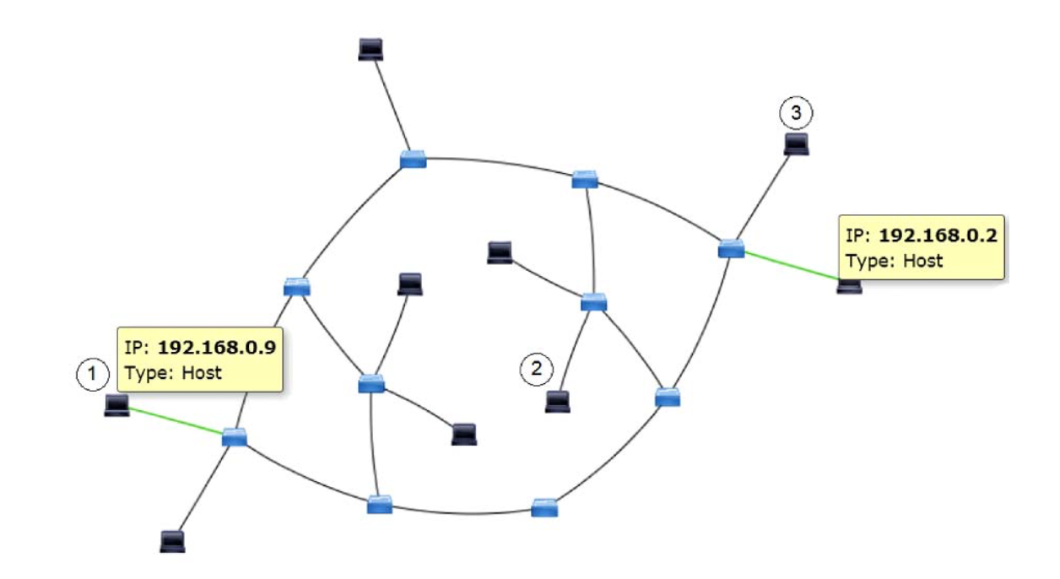

Fig 3.5 Physical-network topologies detected by OpenDaylight.

Table 3.2 The transmission time and average bandwidth with and without dynamic flow scheduling.

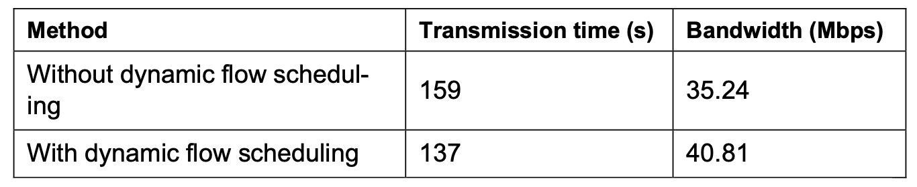

The performance gain of the proposed dynamic scheduling was heavily dependent on the rates and duration of the flows in the network. This experiment demonstrates the feasibility of build- ing a working prototype of dynamic flow scheduling in the CLOUDS-Pi platform.

* + 1. Virtual Machine Management

Live migration, one of the core concepts in modern datacenters, allows moving a running VM between physical hosts with no impact on the VM’s availability. While VMs in datacenters are often migrated between hosts to reduce energy consumption or for maintenance purposes, live VM migration also provides an opportunity to enhance link utilization and reduce network-wide communication costs. This can be done by relocating communicating VMs to nearby hosts with fewer connecting links in the higher layers of the datacenter network topology.

We measured the bandwidth between two communicating VMs running on physical hosts (hosts 192.168.0.2 and 192.168.0.9 in Figure 5) connected through core switches. We ran experiments by moving these two VMs closer to each other in the network topology. First, we performed a VM migration to remove any core switches on the connecting shortest path and then another mi- gration to remove both the core and aggregation switches. Meanwhile, we investigated the im- pact of migrations on the available bandwidth.

During the experiment, random and synthetic background traffic was generated between all hosts in the network, both periodically and continuously. The graph in Figure 6 shows the available bandwidth from the source VM (labeled 1 in Figure 5) to the destination VM (labeled 2 in Figure 5), measured with the iperf3 tool. Before the first migration (time 0 to 70), the source VM was placed on a different pod from the destination VM. As shown in the graph, during this period the average bandwidth was roughly 71 Mbps and fluctuated considerably owing to the background traffic generated by other hosts.

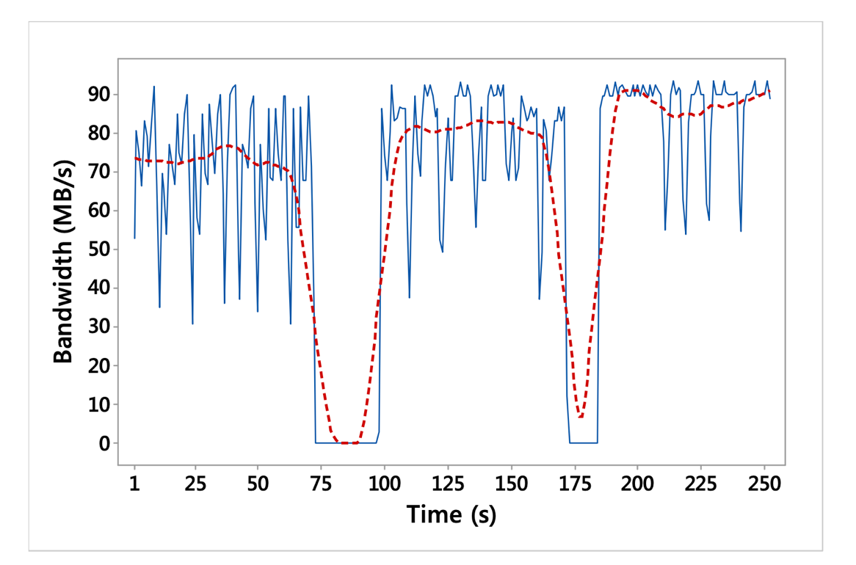

Fig 3.6 The impact of VM live migration on the bandwidth of a communicating VM pair.

After 70 seconds, a live VM migration was performed to move the source VM to the host labeled 2 in Figure and connected to a different access switch in the same pod of the destination VM. During the live-migration process, the VMs’ networking became unavailable for a short period. After this migration, the bandwidth fluctuated less and increased to 79 Mbps on average because fewer background flows conflicted with the traffic of the source-and-destination VM pair.

The last migration was done after 170 seconds of the experiment. The source VM was migrated to the host labeled 3 in Figure, which was connected to the same access switch as the destination VM. With this migration, bandwidth became more stable and rose to an average of 86 Mbps, where the least background traffic affected the networking performance of the VMs.

The experiment demonstrates the feasibility of building a prototype system allowing network- wide communication minimization in a cloud datacenter. It also opens up the possibility of re- search on joint VM and traffic consolidation. Other interesting research ideas include how to select the destination for a VM migration to get the best bandwidth or performance after migration, how to jointly consolidate VMs and traffic in datacenters, and how to place virtual network function (VNF) instances in a datacenter supporting service function chaining (SFC).

**Chapter 4**

**Discussion and Future Direction**

Our results demonstrate the potential of the CLOUDS-Pi platform in enabling investigation of different aspects of SDN-enabled cloud computing. One of the main benefits of CLOUDS-Pi for conducting research on SDN in cloud computing, compared to other prototyping methods or em- ulators such as Mininet, is the option of VM management. VM management and, in particular, the possibility of VM migration are essential aspects of cloud computing that allow for VM con- solidation to reduce power consumption and increase cost efficiency. Thanks to the OpenStack setup in our platform, we can jointly leverage virtualization capabilities and SDN for performing research on VM and traffic consolidation.

Another benefit of CLOUDS-Pi is the possibility of conducting innovative research in traffic control and network management with high accuracy and performance fidelity. As shown in the first use case, using ODL’s northbound APIs and its flow-scheduling feature, we can investigate dynamic traffic engineering and load balancing for reducing network congestion with a level of confidence that would otherwise be beyond our reach.

Apart from network management, research directions that can be followed on our testbed plat- form include, but are not limited to, security (e.g., network intrusion detection), SFC, and appli- cation-specific networking.

The current setup of CLOUDS-Pi has a limited number of resources. The number of switches and hosts used in building the CLOUDS-Pi platform is far from enough to test the scalability of approaches that need to be deployed in cloud datacenters hosting tens of thousands of servers and thousands of network switches. In addition, since we are using USB 2.0 ports on Raspberry Pis with a nominal bandwidth of 480 Mbps and 100 Mbps USB-to-Ethernet adapters as switch ports, our network bandwidth, even though suitable for the scale of our testbed, is much lower than gigabit or terabit networks used in real-world cloud datacenters. Although CLOUDS-Pi of- fers a suitable environment to carry out empirical research on SDN and cloud computing without the expenditure of full-size testbeds, we recommend the use of simulators such as CloudSimSDN to evaluate the scalability of policies.

Besides our testbed limitations, SDN itself currently faces some challenges, such as scalability, reliability, and security, that hinder its performance and application. The logically centralized control in SDN causes scalability concerns, and controller scalability especially is one of the problems that need particular attention. The scalability issue of SDN becomes more evident in

The centralized control plane of SDN—for example, the single-host deployment of the ODL controller in our testbed—has a critical reliability risk, such as a single point of failure. To tackle this problem, running backup controllers is a common approach. However, defining the optimal number of controllers and the best locations for the primary and backup controllers is challeng-  
bution with the use of east–west APIs is one way to overcome computational loads on the controller , but it brings consistency and synchronization problems into the picture. It also requires standard protocols for an interoperable state exchange between controllers of different types.

SDN has two fundamental security issues:

* The potential exists for a single point of attack and failure.
* The southbound API connecting the controller and data-forwarding devices is vulnerable to interception and attacks on communication.

Even though TLS/SSL encryption techniques can be used to secure communication between controllers and OpenFlow switches, the configuration is very complicated, and many vendors do not provide support for TLS in their OpenFlow switches by default. SDN security is critical since threats can degrade the availability, performance, and integrity of the network. While many efforts are currently being made to address SDN security issues, this topic is expected to draw increased attention in the coming years.

**Chapter 5**

**Conclusion**

* 1. **Conclusion**

We presented CLOUDS-Pi, a low-cost testbed environment for SDN-enabled cloud computing. All aspects of our platform, from its overall architecture to particular software choices, were explained. We also demonstrated how economical computers such as Raspberry Pis could be used to mimic a network of OpenFlow switches in an SDN-enabled cloud datacenter on a small scale. In order to evaluate our testbed, two use cases for dynamic flow scheduling and VM man- agement were identified. We discussed the benefits and limitations of CLOUDS-Pi as a research platform for different aspects of SDN in clouds, and we proposed future research directions. Our work demonstrates the potential of the CLOUDS-Pi platform for conducting practical research and prototyping SDN-enabled cloud-computing environments.

OpenSSH is an application that allows you to securely access Linux systems remotely over the network. You can use OpenSSH simply for secure file sharing. But it also allows you to log on to a system and control it over the network, even using the GUI, just as if you were sat in front of it. The default installation of Linux on your Raspberry Pi should have “SSH daemon” running. This means that your Raspberry Pi is listening on port 22 for a remote computer asking to make a connection to it. In your case, this will probably mean your normal desktop or laptop computer.

I found that Raspberry Pi personal cloud storage, prescribed trust and privacy protection on its users, while maintaining security as its domain. Users, for the most part, accepted this script; however, some varying levels of trust were observed in users.

**References**

1. W. Han et al., “SD-OPTS: Software-Defined On-Path Time Synchronization for Information-Centric Smart Grid,” Proceedings of the 2017 IEEE Global Communications Conference (GLOBECOM 2017), 2017, pp. 1–6.
2. D.S. Linthicum, “Software-defined networks meet cloud computing,” IEEE Cloud Computing, vol. 3, no. 3, 2016, pp. 8–10.
3. M. Gupta, J. Sommers, and P. Barford, “Fast, accurate simulation for SDN prototyping,” Proceedings of the 2nd ACM SIGCOMM Workshop on Hot Topics in Software Defined Networking (HotSDN 13), 2013, pp. 31–36.
4. J. Son et al., “CloudSimSDN: Modeling and simulation of software-defined cloud datacenters,” Proceedings of the 15th IEEE/ACM International Symposium on Cluster, Cloud and Grid Computing (CCGrid 15), 2015, pp. 475–484.
5. B. Lantz, B. Heller, and N. McKeown, “A network in a laptop: rapid prototyping for software-defined networks,” Proceedings of the 9th ACM SIGCOMM Workshop on Hot Topics in Networks (HotNets 10), 2010, p. 19.
6. H. Kim, J. Kim, and Y.-B. Ko, “Developing a cost-effective OpenFlow testbed for small-scale software defined networking,” Proceedings of the 16th IEEE International Conference on Advanced Communication Technology, 2014, pp. 758–761.
7. H. Yu et al., “Zebra: An East-West Control Framework for SDN Controllers,” Proceedings of the 44th IEEE International Conference on Parallel Processing, 2015, pp. 610–618.
8. A. Dixit et al., “Elasticon: An elastic distributed SDN controller,” Proceedings of the 10th ACM/IEEE Symposium on Architectures for Networking and Communications Systems, 2014, pp. 17–28.
9. F.P. Tso et al., “The Glasgow Raspberry Pi Cloud: A scale model for cloud computing infrastructures,” Proceedings of the 33rd IEEE International Conference on Distributed Computing Systems Workshops, 2013, pp. 108–112.
10. M. Al-Fares, A. Loukissas, and A. Vahdat, “A scalable, commodity datacenter network architecture,” ACM SIGCOMM Computer Communication Review (SIGCOMM 08), vol. 38, no. 4, 2008, pp. 63–74.
11. C.E. Hopps, “Analysis of an equal-cost multi-path algorithm,” RFC2992, ACM, 2000.
12. J. Son et al., “SLA-aware and energy-efficient dynamic overbooking in SDN- based cloud datacenters,” IEEE Transactions on Sustainable Computing, vol. 2, no. 2, 2017, pp. 76–89.
13. A.M. Medhat et al., “Service function chaining in next-generation networks: State of the art and research challenges,” IEEE Communications Magazine, vol. 55, no. 2, 2017, pp. 216–223.
14. M. Karakus and A. Durresi, “Control plane scalability issues and approaches in software-defined networking,” Computer Networks, vol. 112, 2017, pp. 279–293.
15. I.F. Akyildiz et al., “A roadmap for traffic engineering in SDN-OpenFlow networks,” Computer Networks, vol. 71, no. C, 2014, pp. 1–3.
16. S. Scott-Hayward, G. O'Callaghan, and S. Sezer, “SDN security: A survey,”

Proceedings of the 2013 IEEE Conference on SDN for Future Networks and Services (SDN4FNS 13), 2013, pp. 1–7.

1. Abraham, (2009). Autonomic Clouds on the Grid. Journal of Grid Computing, 1-18.
2. Aderemi A. Atayero*, Oluwaseyi Feyisetan**. (October 2011). Journal of Emerging Trends in Computing and Information Sciences. *Security Issues in Cloud Computing: The Potentials of Homomorphic Encryption*. VOL. 2 (NO. 10), p 547-550.
3. Andrew Tabona. (2013). *The Top 20 Free Network Monitoring and Analysis Tools for Sys Admins.* Available: http://www.gfi.com/blog/the-top-20-free- network-monitoring-and-analysis-tools-for-sys- admins/. Last accessed 2nd November 2014.
4. Armbrust, M., Fox, A., Griffith, R., Joseph, A., Katz, R., Konwinski, A., Lee, G., Patterson, D., Rabkin, A., Stoica, I. and Zaharia, M. (2009). Above the Clouds: A Berkeley View of Cloud Computing. Technical Report. University of California at Berkeley.
5. Bessie. (December 2012). *Ouya vs Raspberry Pi.* Available: http://ouyaforum.com/showthread.php? 755-Ouya-vs-Raspberry-Pi. Last accessed 11 October 2014.
6. Boniface, M., Nasser, B., Papay, J., Phillips, S., Servin, A., Yang, X., et al. (2009). Platform-as-a- Service Architecture for Real-time Quality of Service Management in Clouds.
7. Christodorescu, M., R. Sailer, D. L. Schales, D. Sgandurra, and D. Zamboni (2009). Cloud security is not (just) virtualization security. In Proceedings of the ACM Cloud Computing Security Workshop (CCSW), pp. 97–102.
8. Cisco. (2013). *Cisco Packet Tracer.* Available: http://www.packettracernetwork.com/. Last accessed 2018th November 2014.
9. Cloud Security Alliance, “Top Threat to Cloud Computing V1.0,” March 2010. [Online]. Available: https://cloudsecurityalliance.org/topthreats/csathrea ts.v1.0.pdf
10. CN VR. (17 September 2014). *The Raspberry Pi B.* Available: http://www.ebay.com/itm/CN-Ver- Raspberry-Pi-2-0-Model-B-512MB-ARM11-Linux- System-Development-Board-Kit-/261189408347. Last accessed 11 October 2014.
11. David Oven. (2013). *Ethernet Tutorial - Part I: Networking Basics.* Available: http://www.lantronix. com/resources/net-tutor-etntba.html. Last accessed 2018th November 2014.
12. Foster, I., Zhao, Y., Raicu, I. & Lu, S. (2008). Cloud Computing and Grid Computing 360-Degree Compared, University of Chicago, 10-56.
13. ICO. (2013, Jul.) “Privacy impact assessment handbook,” v2.0, Information Commissioner’s Office, UK. [Online]. Available: //www.ico.org.uk/pia handbook html PIAhandbookV2.pdf
14. ipv6launch.org. 2012. IPV6launch.  
    Available at: http://www.worldipv6launch.org/ support/. [Accessed 09 April 2018].
15. jaipa.or.jp. 2011. Current status and the future direction of IPv6 in Japan. [ONLINE] Available at: http://www.jaipa.or.jp/ipv6day/data/111121_iaetf. pdf. [Accessed 09 April 2018].
16. James Hilton. (June, 2013). *Designing and Building the Best Small Office Network From the Ground Up.* Available: http://www.networkcomputing.com/ netdesign/soho1.html. Last accessed 2018th November 2014.
17. Jhony Jackson. (2012). *What is a Computer Network.....?.* Available: http://www.e-tutes.com/. Last accessed 2018th November 2014.
18. Lantronix. (2014). *Networking Tutorials.* Available: http://www.lantronix.com/resources/networking. html. Last accessed 2018th November 2014.
19. Marianthi (2013), “Data protection jurisdiction and cloud computing when cloud users and providers subject to eu data protection law are? the cloud of unknowing, Part 3,” International Review of Law, Computers & Technology, vol. 26, pp. 2–3, 2012
20. Meetings.apnic.net. 2012. IPV6 deployement of KDDI. [ONLINE] Available at:http://meetings.apnic. net/__data/assets/pdf_file/0003/44976/ipv6_deploy ment.pdf. [Accessed 09 April 2018].